**Practical No 1**

**Aim:** Creation of Dimensions and Fact tables.

**Solution:**

Open Application -> Microsoft SQL Server 2008 R2 -> SQL Server

Management Studio

1. Select Connect Tab -> Database Engine -> Select Server Name(local)

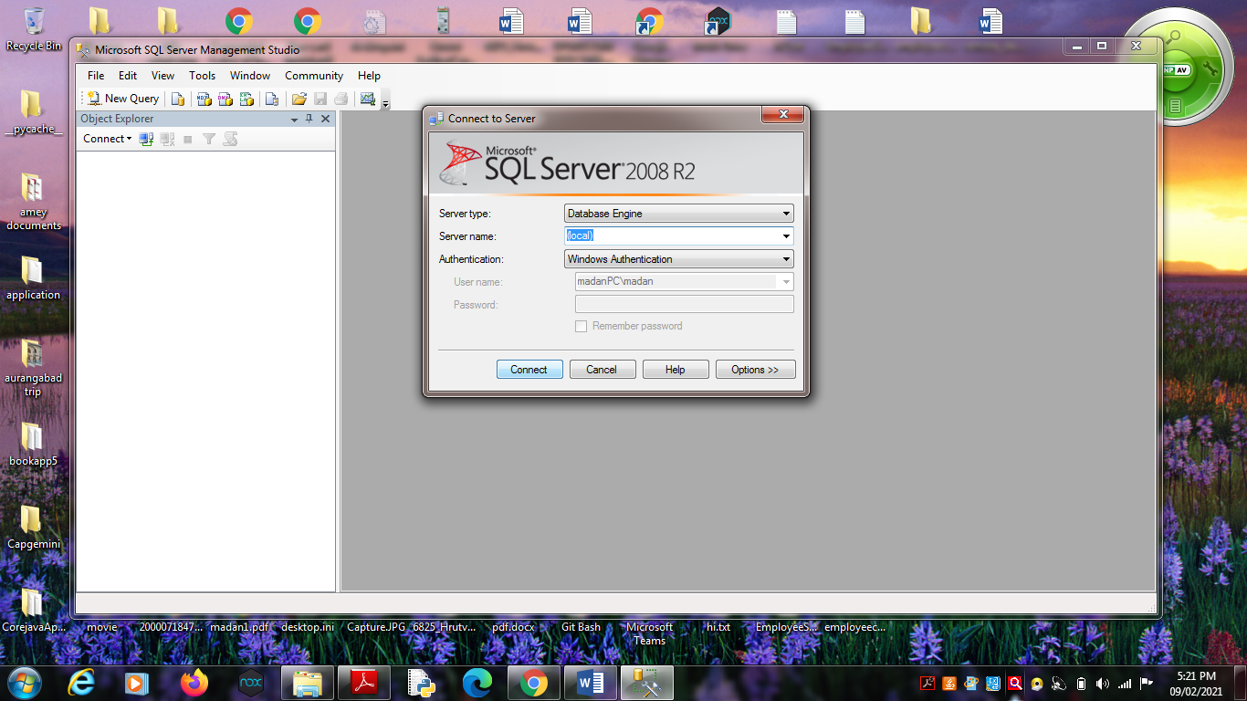

2. Right Click the Database -> New Database

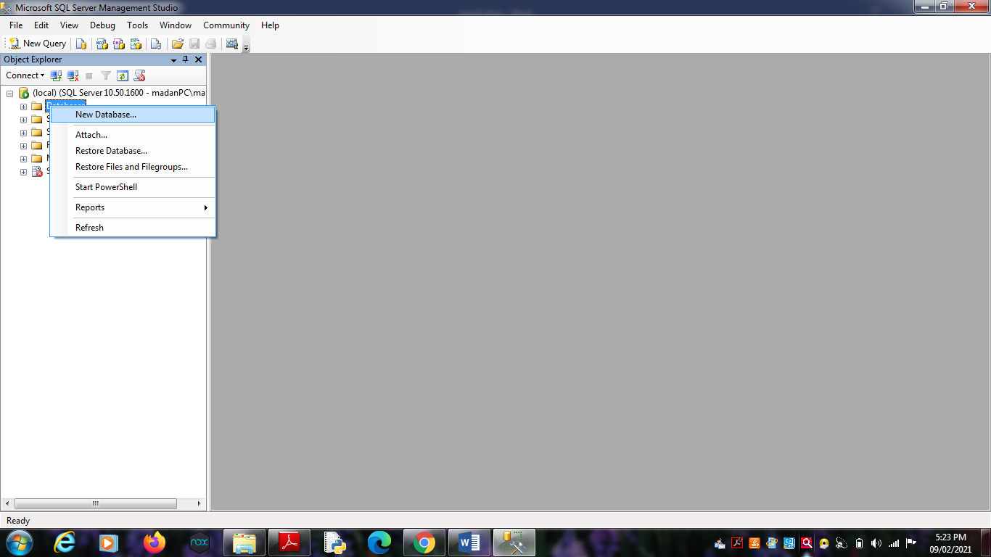

3. Types “SalesProduct” as the database name, click on OK to close the

dialog box and to create the database.

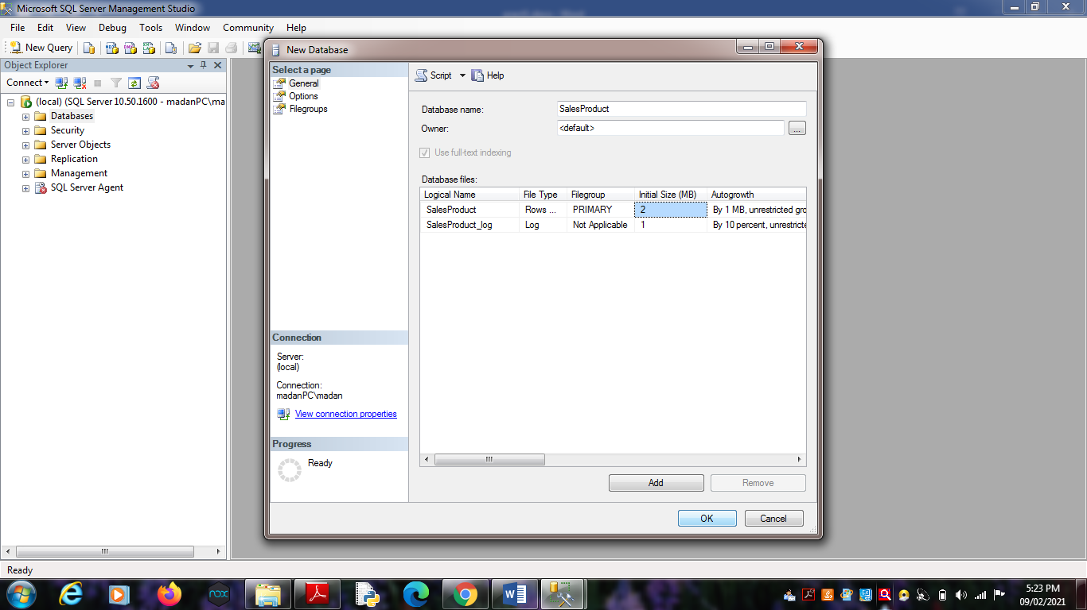

**Create a Database Diagrams**

Expand the “SalesProduct” database folder.

1. Click on Database Diagrams to expand it

On click of it, above Dialog box appears, click on Yes to close it.

2. Right Click on Database Diagrams -> New Database Diagrams

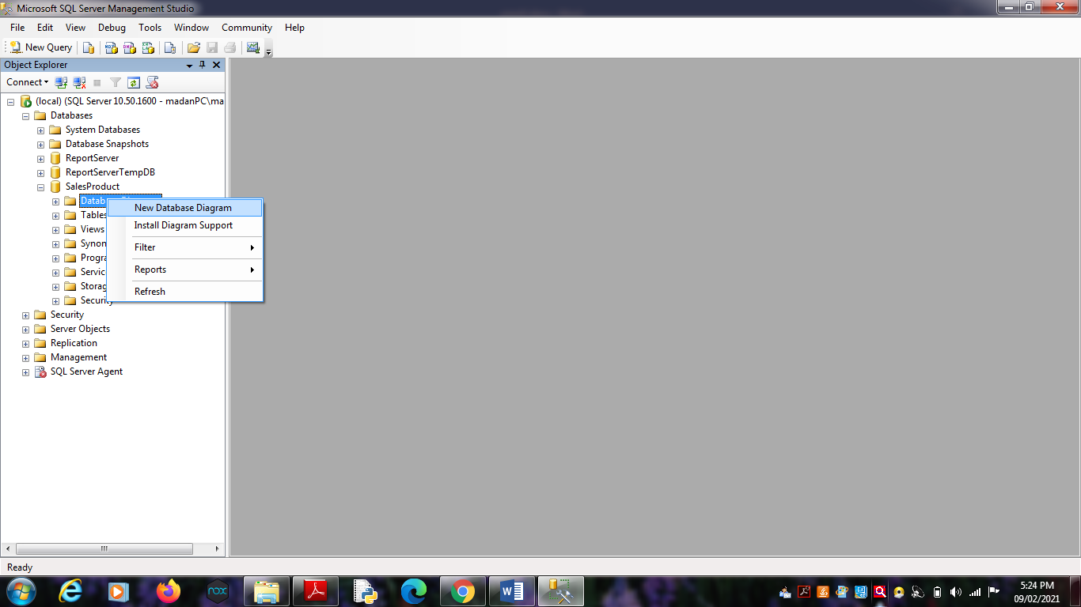 3. Create fact and Dimension Tables. (Right click on surface, choose

New Table to add tables on Database Diagrams.)

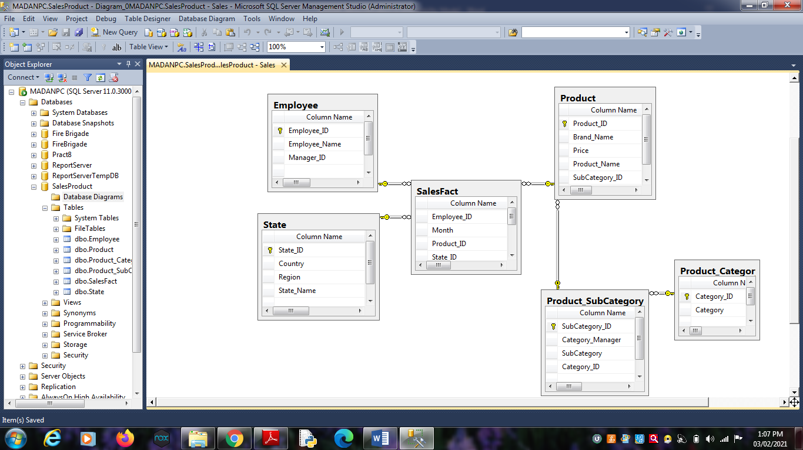

4. Establish relationship between fact and dimension tables.

5. Save Database Diagrams with name as “Sales”. (After saving

Database Diagrams fact and dimension tables are automatically

placed in Table tab.)